Autumn 2022

Dmitry Semenov

[dsemenov@uef.fi](mailto:dsemenov@uef.fi)

+358-50-3043941

**Tasks #1. White correction**

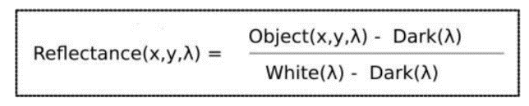

Data is **ASI autumn 2022** folder:

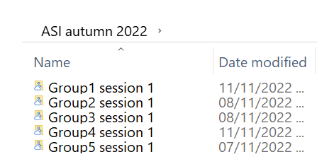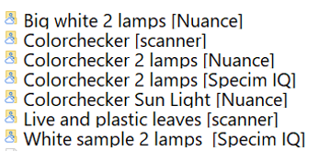

Firstly, do white correction (+ dark for scanner case):

1. Colorchecker [scanner]

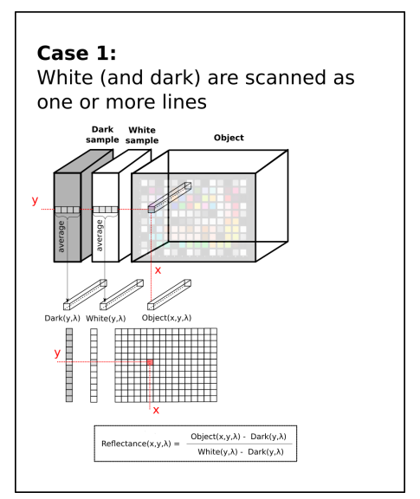

1. Color Checker 2 lamps [Specim IQ] + White Sample 2 lamps [Specim IQ]

No dark correction

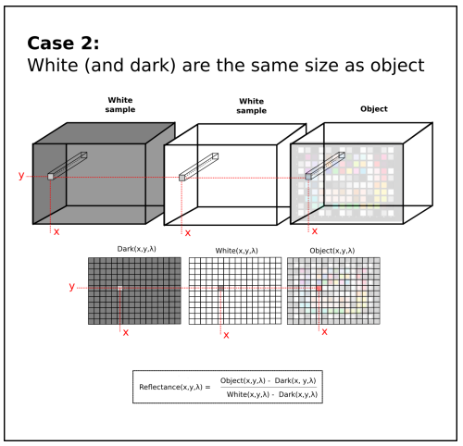

1. Color Checker 2 lamps [Specim IQ] using **left** and **right** white samples inside the image

No dark correction

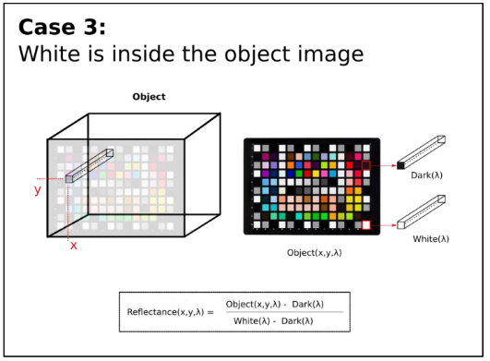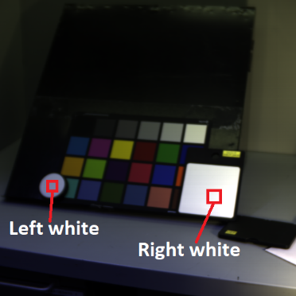

1. Plot in the same plot **green spectra** (4 corrected green spectra obtained from each correction case)
2. Plot in the same plot red **spectra** (4 corrected red spectra obtained from each correction case)
3. Plot in the same plot **blue spectra** (4 corrected blue spectra obtained from each correction case)

**Tasks #2. Nuance camera**

Read Nuance camera **Colorchecker 2 lamps [Nuance]** data, build ENVI spectral cube, save it as ENVI with hdr file.

You may use this code as an example: **Nuance to ENVI.ipynb** in **ASI autumn 2022** folder

Use such a hdr file:

ENVI description = {File Imported into ENVI}

ENVI description = {File Imported into ENVI}

file type = ENVI

samples = 1392

bands = 33

lines = 1040

interleave = bil

data type = 12

header offset = 0

byte order = 0

Try to open result (raw+hdr) with Freelook. It should be successful.

Do white corrections for this Nuance ENVI file. Plot red, green, blue spectra from Specim IQ and from Nuance after the same white correction is applied to both.

Naunce RGB_freelook

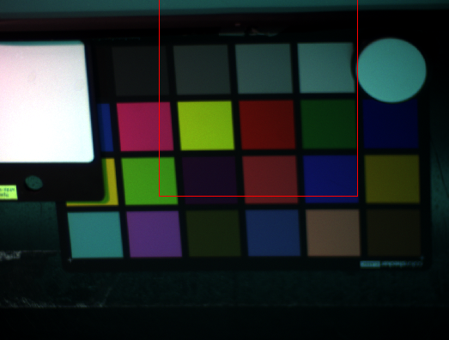

Naunce_gray_freelook

